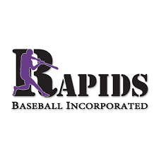
Rapids Baseball Inc. 2022 Golf Tournament Information

Monday, November 7th, 2022 at Stonehenge Golf and Country Club
Shotgun Start at 10 AM – 4 Person Captain’s Choice
Box Lunch, Drinks, and Snacks Will be Provided

Gifts for longest drive, closest to the pin, and team play

Rapids Baseball Inc. is a non-profit organization, and all contributions are tax deductible. We appreciate your support.

Sponsorship Opportunities: This year we had 122 games at the baseball facility among season play, tournament rental play, and Fall Ball, so the sponsorship banners get quite a bit of attention.

Rapids Sponsor: $1,000 Includes: ● Foursome ● Separate signage (3ft x 5ft banner) on the baseball field for one-year ● Recognition on a banner inside of the concession area during baseball season ● Individual hole signage during tournament ● Recognition in the baseball season program
Concession Sponsor: $750 Includes: ● Foursome ● Recognition on a banner inside of the concession area during baseball season ● Individual hole signage during tournament ● Recognition in the baseball season program
Hole Sponsor: $250 Includes: ● Recognition on a banner inside of the concession area during baseball season ● Individual hole signage during tournament ● Recognition in the baseball season program
Golf Only: $125 individual, $500 foursome
Send payment via check to: Rapids Baseball Incorporated, P.O. Box 73611, Richmond, VA 23235 or Pay Online

